Operational Plan



**1st & 2nd July**

**8th & 9th July**

**2023**

V2.5 Updated 30/06/23

CMEDCRAFT

Company Introduction

Quad Medical was established with one main aim: to provide our clients with unrivalled medical assistance for their event or venue. Safety is always paramount and the ever present risk of accident or sudden illness which can affect staff or visitors must always be taken into consideration. Our prime objective is to assist the client to run an event which is enjoyed by all who attend it and which is remembered for all the right reasons. Naturally clients want to ensure that they have medical cover in place to deal with health problems calmly and professionally with minimal disruption to the event. Quad Medical are here to help: Our knowledgeable and experienced management team will provide the right solution for all medical requirements. As no event is ever the same, we create a bespoke package of medical cover that suits each unique event, leaving clients secure in the knowledge that, should the need for medical assistance be required, our highly trained team will be on hand in an instance to help.

Service Quality

The events industry is a large and dynamic one which is constantly growing. We understand that it can be difficult for event producers to know how to source high quality, safe and effective medical services. Quad Medical Limited is a Care Quality Commission regulated company. The Care Quality Commission (CQC) are the independent regulators for health and social care in England. Not all event medical providers are registered with the care quality commission. At Quad Medical Limited however, we work tirelessly to ensure the safety and quality of our service is upheld by maintaining CQC standards and our registration. The Care Quality Commission regulate Quad Medical in the same way hospitals and national ambulance services across England are regulated, through regular monitoring, inspection, and public publication of their findings. This ensures that we remain safe, effective, and caring and maintain our practice as healthcare professionals in line with current evidence and legal guidance. In summary this means that event producers can rest assured that they have employed a professional and high-quality healthcare service.

Venue Background

Set within Silvertown Quays, the expansive 400,000 sq ft open-air, waterside location will breathe new life in the Royal Docks, unlocking its potential with a year-round curated programme of creatively bold and culturally innovative events. Silverworks Island is a transformable space offering a canvas with endless possibilities. The space will continuously evolve to create new and exciting environments filled with a variety of events driven by innovation and imagination.

Venue Background

In summer 2023 Silverworks Island will be hosting two multi-stage all day events over two weekends. The site is in the grounds of the impressive derelict Millennium Mills and will feature up to three stages and a wide range of food and beverage traders, catering for up to 19,999 customers.



Address

Silvertown



Burt Road

Royal Docks

London

E16 2BY

Travel information

Silverworks Island is well served by the public transport network, allowing guests to reach the site easily via Docklands Light Railway (DLR), National Rail, River, London Underground & London Overground (both followed by a connection to the DLR or short walk).

THERE IS NO STAFF PARKING AVAILABLE FOR SHOW DAY

Venue map TBC

QML Staffing

Staffing requirements are calculated using the National Standard Event Guide, by a Senior Quad Medical Manager and agreed with the event organiser.

|  |  |
| --- | --- |
| Build & Derig Medical staffing x 1 FREC3 | |
| Monday 19th June | Day |
| Tuesday 20th June | Day |
| Wednesday 21st June | Day |
| Thursday 22nd June | Day |
| Friday 23rd June | Day |
| Saturday 24th June | Day |
| Sunday 25th June | Day |
| Monday 26th June | Day |
| Tuesday 27th June | Day |
| Wednesday 28th June | Day |
| Thursday 29th June | Day |
| Friday 30th June | Day & Night |
| Saturday 1st July | Night |
| Monday 3rd July | Day |
| Tuesday 4th July | Day |
| Wednesday 5th July | Day |
| Thursday 6th July | Day |
| Friday 7th | Night |
| Saturday 8th | Night |
| Sunday 9th | Night |
| Monday 10th July | Day |
| Tuesday 11th July | Day |
| Wednesday 12th July | Day |

|  |  |
| --- | --- |
| 1st July Medical Staffing  Solid Grooves & Jamie Jones | |
| Resource Type | **Number Required** |
| Duty manager | 1 |
| Doctor | 1 |
| Event Practitioner | 1 |
| ACP | 1 |
| A&E Nurses | 2 |
| Paramedics | 2 |
| Emergency Medical Technicians/ Emergency Care Assistants | 2 |
| Frec 3/First responder | 10 |
| Welfare | 13 |
| Controller | 1 |
| Total Number of staff | 34 |

|  |  |
| --- | --- |
| 2nd July Medical Staffing  A State of Trance | |
| Resource Type | **Number Required** |
| Duty manager | 1 |
| Doctor | 1 |
| A&E Nurses | 2 |
| Paramedics | 2 |
| Emergency Medical Technicians/ Emergency Care Assistants | 2 |
| Frec 3/First responder | 6 |
| Welfare | 4 |
| Controller | 1 |
| Total Number of staff | 19 |

|  |  |
| --- | --- |
| 9th July Medical Staffing  Wah in the city | |
| Resource Type | **Number Required** |
| Duty manager | 1 |
| Doctor | 1 |
| Event Practitioner | 1 |
| A&E Nurses | 2 |
| Paramedics | 2 |
| Emergency Medical Technicians/ Emergency Care Assistants | 2 |
| Frec 3/First responder | 10 |
| Welfare | 5 |
| Controller | 1 |
| Total Number of staff | 25 |

|  |  |
| --- | --- |
| 8th July Medical Staffing  1MX LDN MUSIC FESTIVAL | |
| Resource Type | **Number Required** |
| Duty manager | 1 |
| Event Practitioner | 1 |
| Controller | 1 |
| Welfare | 2 |
| Paramedic | 2 |
| EMT/ECA | 2 |
| First responders | 3 |
| Total Number of staff | 12 |

|  |  |
| --- | --- |
| Assets | |
| Resource Type | **Number Required** |
| Emergency Ambulances | 2 per show (+2 for show 1) |

One ambulance will be parked overnight on site between shows as requested.

Itinerary

|  |  |
| --- | --- |
| Saturday 1st July | |
| 1000 | QML Vehicles to be collected from SE9 4AS |
| 1100 | Arrival of QML Vehicles on site  (vehicle movement to cease after 1200hrs) |
| 1130 | QML staff to arrive on site and sign in |
| 1145 | QML staff briefing |
| 1200 | Event Start |
| 2300 | Anticipated event finish |
| 0000 | Staff to be stood down post egress |
| Sunday 2nd July | |
| 1000 | QML Vehicles to be collected from SE9 4AS |
| 1100 | Arrival of QML Vehicles on site  (vehicle movement to cease after 1200hrs) |
| 1130 | QML staff to arrive on site and sign in |
| 1145 | QML staff briefing |
| 1200 | Event Start |
| 2230 | Anticipated event finish |
| 2330 | Staff to be stood down post egress |
| Saturday 8th July | |
| 1000 | QML Vehicles to be collected from SE9 4AS |
| 1100 | Arrival of QML Vehicles on site  (vehicle movement to cease after 1200hrs) |
| 1130 | QML staff to arrive on site and sign in |
| 1145 | QML staff briefing |
| 1200 | Event Start |
| 2300 | Anticipated event finish |
| 0000 | Staff to be stood down post egress |
| Sunday 9th July | |
| 1000 | QML Vehicles to be collected from SE9 4AS |
| 1100 | Arrival of QML Vehicles on site  (vehicle movement to cease after 1200hrs) |
| 1130 | QML staff to arrive on site and sign in |
| 1145 | QML staff briefing |
| 1200 | Event Start |
| 2230 | Anticipated event finish |
| 2330 | Staff to be stood down post egress |

Clocking in & Out

On arrival staff are to clock in on the details below or sign in on the register where there is no access to the internet. All radios and uniform must also be signed out. Staff must also record the name and number of their next of kin for use in

the event of an emergency and the management team need to contact them.

|  |
| --- |
| **Clocking In** |
| Qr code  Description automatically generated  https://www.smartsurvey.co.uk/s/quadclockin/ |

At the end of the shift staff are required to clock out and return their equipment or loaned uniform including hi-vis jackets

|  |
| --- |
| **Clocking Out** |
| Qr code  Description automatically generated  https://www.smartsurvey.co.uk/s/Quadclockout/ |

Staff Identification and Uniform

All staff will be provided with the appropriate high visibility tabard for the event. No personal tabards or those from other companies/services may be worn under any circumstances. Staff are not allowed to wear clothing displaying any other company’s logo. Those that fail to adhere to the uniform policy may be asked to leave without pay. Staff are expected to wear black, bottle green or navy uniform trousers (Jeans and leggings are unacceptable), a plain white t-shirt and sensible flat black working shoes. Staff may also bring plain black jumpers, hoodies or coats.

Scope of Practice

Throughout this document the use of the term ‘registered person’ refers to a Doctor, Nurse, Paramedic or NHS Trained and experienced EMT, who are to practice with in the remits of their registering body (GMC, HPCP or NMC) competence and experience.

Student Nurses and Paramedics

Student nurses and Paramedics are employed by QML as First Aiders providing they have evidence of appropriate life support training such as a first response in emergency care level 3 and relevant experience. As such they are only permitted to practice within the scope of a FREC 3 provider, providing basic care and treatment.

Under no circumstances is a first aider to administer medications of any type. They are also not permitted to use any extended skills including the advanced assessment of patients with an ECG. There will always be a trained and registered Paramedic, Nurse or Doctor within the first aid post to provide advanced patient assessment and treatment should it be needed. First Aiders are to escalate their concerns to one of these members of staff when needed.

Staff use of Social Media

In the interests of client and patient confidentiality, QML staff are not permitted to post pictures of themselves or other members of the QML team on social media. An allocated member of staff may capture images which can then be vetted and shared with staff should they wish. Staff who do not wish to be included in any images (which QML may publish in the future) should inform Paul Saddington at the start of the event.

Medical Risk Assessment

This venue is licensed for up to 19,000 visitors. Based on our experience of events of this nature the following medical risks are most highly anticipated. This list is not exhaustive and a wide range of ‘one-off’ non-event related medical presentation are additionally accounted for.

|  |
| --- |
| High Severity—Low/Medium Probability |
| * Isolated incidences of acute cardiac conditions * Hypovolaemic / Electrolytic medical problems related to fluid and / or electrolyte loss * Exacerbation of pre-existing medical problems induced by exercise, i.e. Asthma, diabetes etc. Or by patients losing or unable to access medications (Ventolin, insulin etc.). * Hypothermia especially if cold or wet * Injuries from assault including acid attacks * Effects of intoxication from excess alcohol or recreational drug use |
| Low Severity—High Probability |
| * Cuts & Bruises—related to trips & falls (especially in wet) * Musculoskeletal injuries—Sprains, strains etc. * Various spontaneously recovering exhaustion / weakness / dizziness / collapse episodes |

**Intention of Medical Services**

The purpose of the medical operations at this event is:

1. To ensure that qualified medical staff and equipment can access a casualty at any point on the event site within 5 minutes of an incident being accurately reported
2. To provide high profile medical staff and facilities so that any participants seeking medical attention can easily self present to medical staff
3. To ensure that where appropriate, non- ambulatory patients can be transported from their location to hospital, or to on site medical facilities
4. To provide fully equipped medical treatment area where patients can be assessed and treated by medical staff, including full resuscitation facilities.
5. To provide a communications link between event personnel and all medical staff to ensure medical resources can be quickly and appropriately dispatched when required.
6. To maintain accurate records of all medical treatments so that event statistics can be compiled and legal interests of all medical staff are best protected

Excel Centre

X2 First responders plus X2 welfare staff will be positioned outside the Excel Centre for the duration of all four shows.

First Aid Post

There will be a First aid post situated at a location specified by the event organiser. The First aid post structure shall be provided and set up by the event organiser, whilst the interior shall be set up by Senior QML management and logistics staff a day prior to the event. This shall be done from a pre-packed and checked logistics support vehicle. Please refer to image 1 below for an example of how the post will be laid out.

Image 1: First aid post layout example

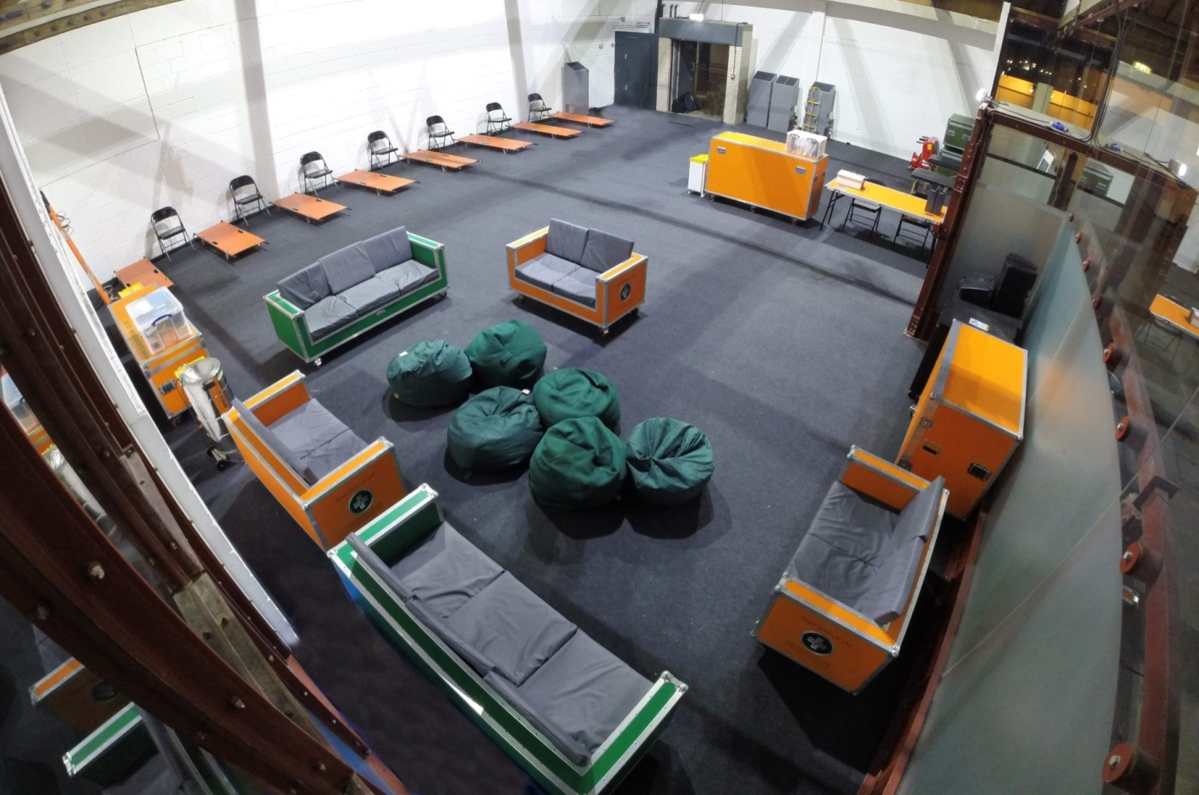

Treatment Areas / Triage system and response

The First aid post shall be divided into Six distinct areas;

1. Triage
2. Seated Minor injuries area
3. Major Ailments bedded area
4. Resuscitation area
5. Welfare area
6. Staff break/refreshment area

On self presentation to the first aid post, patients will be greeted by triage staff who will take a brief description of the presenting complaint and direct the patient to the appropriate area within the first aid post. As per the agreed Covid plan, patients will be assessed in line with government guidance.

## Clinical guidelines

All assessments must be in accordance with training received and as per individual scope of practice. All staff will be expected to complete online National early warning scores training. All assessments, wherever possible, must be made in the Medical Centre.

Allocation to minor injuries

Patients who require brief and minor treatment that do not necessitate any further observations of physiological parameters such as heart rate and blood pressure etc. can be directed to the minor injuries area.

Minor Treatment Records

These include all basic non-invasive patient contacts and advice only situations. Specifically, small grazes, blisters, non-serious muscular skeletal injuries (minor sprains & strains). These records are only for use with patients who return immediately to the event, or who require no further treatments or examination. It will therefore be assumed that all patients recorded as minor treatments left the medical care immediately after receiving treatment. If this is not the case then a full Patient Report Form (PRF) should be completed. (See below). It is the responsibility of the QML staff member treating the patient to complete the form to clearly and accurately, ensuring the location and date of the event is documented on every sheet used.

Allocation to Majors area;

Patients, who require the use of a bed due to injury or illness or require a period of further assessment and observation beyond initial assessment by the triage nurse, shall be directed to the major’s area. Within this area the patient shall be cared for by an allocated member of QML staff who will resume the responsibility of care for that patient until they have been formally handed over to an appropriately skilled colleague or discharged.

All patients allocated to the Majors area will require at least one set of observations charted on the National Early Warning Scores 2 Chart and escalation procedure adhered to as follows:

|  |  |  |
| --- | --- | --- |
| **NEWS GRADED RESPONSE STRATEGY** | | |
| **NEWS SCORE** | **Frequency of monitoring** | **Clinical Response** |
| **0** | Hourly or if patient condition changes | Continue routine NEWS monitoring with every set of observations |
| **Low**  **1- 4** | Hourly or if patient condition changes | Place NEWS in context of clinical presentation if patient appears unwell despite low NEWs then increase monitoring as appropriate |
| **Medium**  **Total: 5 Or**  **≥3 in any parameter** | Increase Frequency to every 15 mins and record half hourly a | 1. Registered person or event lead  must assess the patient  2. Check blood glucose |
| **High**  **≥7** | Increase frequency to continuous observations & document minimum 15 min intervals | 1. Clinical lead must assess patient  2. Check blood glucose  3. Consider immediate transfer to hospital |

Patient Report Forms:

These are to be completed for all patients not in the minor treatment category. All fields are self-explanatory. Please note that a form should be completed for each patient contact. It is the responsibility of the QML staff member treating the patient to complete this form and to ensure that all PRF’s are legible and complete in black ink. Completed forms should be returned to the duty controller for securing as soon as completed.

Documenting Escalation of patients from minors to majors

To ensure accurate statistics are collated for the event, patients who are initially entered on a minor treatment form and then require an increased level of care, outside the scope of the minor treatment form, then a full clinical records form should be completed. The initial entry onto the minor injuries form should then be crossed off with a single line. It is also important that the name of the person treating any patient is clearly recorded.

Allocation to the Resuscitation area;

Patients with life or limb threatening injury or illness shall be directed to the resuscitation area, where the responsibility for their call shall be handed over to a registered person. The team clinical lead shall assess all patients who are being cared for in the resuscitation area and promptly decide if they require hospitilisation or are to remain on site for treatment and observation. Those who are for close observation and continued treatment can be stepped down to the Major’s area with a clear plan of care in place. Those who require hospitilisation will be stabilized by the nursing staff and clinical lead in order to allow the Paramedic ambulance crew to prepare for taking over the care of the patient and for transporting the patient to hospital. Whilst in resus, the patient should be placed on continuous monitoring with observations being recorded every 15mins. At hospital the PRF is to be copied with the copy being given to the hospital staff and the original copy returned to the event duty manager on return of the ambulance crew back to the event site.

**RED FLAGS**

Any patients displaying ‘Red flag’ symptoms must be reviewed immediately by the event clinical lead and placed on continuous monitoring and considered for immediate transfer to hospital.

* Chest pain which is suspected to be cardiac in nature
* Seizures: > 3 mins/First time seizures/as the result of a head injury
* Body temperature 38 degrees and above not settling after 15 minutes rest
* Body temperature greater than 40 degrees at any time
* Heart rate greater than 140 bpm not settling within 15 minutes
* Systolic blood pressure less than 90mmHg or greater than 180mmHg
* Blood pressure Diastolic greater than 110mmHg on 2 separate occasions at least 5 minutes apart
* Significant agitation not settling within 15 minutes
* Trismus (lock Jaw)
* Mechanism of injury or Trauma

Infection control flags

|  |  |  |
| --- | --- | --- |
| **ISOLATION ALERTS** | | |
| **If yes to any of the following inform duty manager and isolate patient** | **YES** | **NO** |
| Confirmed COVID-19 or other communicable disease |  |  |
| Symptomatic of COVID 19 or other communicable disease (see QML Isolation guidance) |  |  |
| Sudden onset Diarrhoea/vomiting with no obvious cause |  |  |
| Obvious contamination with harmful substance |  |  |

Patients presenting with any of the above and answering yes must be escalated immediately to the duty manager who will arrange an area away from other patients for this patient to be cared for.

Designated Vehicles

The festival has two designated emergency ambulances to convey patients to hospital as required. Vehicles should not be used as general treatment areas, however should a patient require privacy, or are being isolated for clinical or compassionate reasons then this will be allowed. Vehicles should remain stationary at their designated areas unless required to convey a patient to hospital or to the treatment area.

It is the responsibility of the allocated Ambulance crew to check their vehicles before the event start and to complete all relevant documentation accurately and in a timely fashion. Any and all vehicle or equipment defects or missing equipment should be reported immediately to the QML management team so that they may ensure both vehicles are fully functioning and fit for purpose throughout the event.

Vehicle Checks

It is the resonsibility of the crew allocated to the vehicle to complete the following checks and documentation at the start of their shift:

|  |  |  |
| --- | --- | --- |
|  | **To be completed** | **Available from** |
| **1** | Mileage log | In the front of the Ambulance cab in paper format within the vehicle folder |
| **2** | VDI | Available in paper format in the vehicle folder or online at:  A picture containing qr code  Description automatically generated  <https://www.smartsurvey.co.uk/s/VDICheck/> |
| **3** | Vehicle cleaning checklist | This can be found in paper form in the vehicle folder or online at:  Qr code  Description automatically generated with medium confidence  <https://www.smartsurvey.co.uk/s/Vehiclecleaning/> |
| **4** | Response bag checklist | Available in the front pocket of the response bag or online at:  Qr code  Description automatically generated  <https://www.smartsurvey.co.uk/s/firstaidbag/> |
| **5** | Equipment and consumables checks | Available in paper format in the vehicle folder or online at:  A picture containing qr code  Description automatically generated  <https://www.smartsurvey.co.uk/s/qmlambchecks/> |

Designated Hospital

Receiving hospitals for this event will be allocated by the QML Duty manager in consultation with the Local Ambulance Service, by taking into account the location of the ambulance, traffic conditions, road closures and nature and severity of the patient.

|  |  |  |
| --- | --- | --- |
| Hospital | Address | Facilities |
| Newham University Hospital | Glen Road  London  E13 8SL | Emergency Department |
| Royal London | Whitechapel road  London  E1 1FR | Accident & Emergency  HASU  PCI  Major Trauma Centre |

The QML Duty manager in consultation with the Local Ambulance Service, will decide the most appropriate receiving hospital by taking into account the location of the ambulance, traffic conditions, road closures and nature and severity of the patients condition.

## Discharge of patients

## All patients who have been seen in the Majors area will require one of the additional discharge forms attached to the PRF. Discharge procedures and documentation is as follows:

## Patients must fulfill the discharge criteria before being released from the care of QML. Patients who have been admitted for a period of observation must have had a set of observations completed within 15 minutes before discharge to ensure patients are safe to leave our care.

## Details of friends to whom patients are discharged into the care of must be recorded on the patients discharge form and PRF. Accompanying adults or friends must be able to comprehend any discharge instructions and have full capacity themselves. If you are unsure if an accompanying person is legitimately a ‘friend’ do not discharge the patient into their care and inform the QML duty manager immediately.

## Patients who are medically fit for discharge but who require ongoing emotional or welfare support may be discharged into the care of the welfare team. If the welfare team has assessed a patient who is deemed medically fit but feel that the care of that person is beyond their scope of practice and competency then said person must remain the responsibility of the medical team. This should be highlighted with the QML duty manager.

Discharge against medical advice

## Patients who can demonstrate capacity and who wish to self-discharge before being medically fit to do so will be required to sign a discharge against medical advice form. The QML duty manager should be aware of all patients who wish to self-discharge and patients should be provided with adequate information to make an informed decision as to whether they should leave the care of QML. It should be made clear to patients wishing to self-discharge the reasons why the QML team would like to continue their care and the possible consequences of leaving QML care before the responsible clinician has deemed that person as medically fit for discharge. The person must be able to retain comprehend and recite this information. If the person refuses to sign the disclaimer then this must be stated on the disclaimer which should be signed by both the responsible clinician treating the patient and another member of the QML team who have witnessed the patient receiving adequate information and who also deem the patient to have capacity.

## Welfare

## Welfare means looking after people during their visit to the event. We have a duty of care to our patrons to ensure that they enjoy a safe visit to the event and to help them when they need assistance. The welfare team will identify and rectify/assist and advise customers with non medical issues.

## During this event QML shall be providing a welfare service. Full details of the welfare service can be found in a separate welfare operations document however basic operating procedures are outlined here.

Welfare staff will be responsible for transferring people to the Medical Centre for assessment as and when dictated by the welfare triage tool or where there is concern that a customer has become medically unwell.

Allocation to Welfare

On initial presentation to the first aid tent all patrons shall be assessed by QML triage staff to determine the most appropriate area for the patron to receive care. If a patron attends for non medical reasons they are welcome to use the welfare facilities for comfort, reassurance and emotional support. If however the welfare staff are concerned that there is an underlying medical complaint then a welfare triage form must be completed to assess their continued suitability for welfare. If any observations are above the upper limits or below the lower limit parameters set out below, then the person must be referred from welfare to the medical team:

|  |  |  |  |
| --- | --- | --- | --- |
| **Observation** | **Lower Limit** | **Normal Range** | **Upper Limit** |
| Temperature (oC) | 35.9 | 36 to 37.9 | 38 |
| Respiration rate (per minute) | 11 | 12-20 | 21 |
| SpO2 % | 93 | 94-100 | N/A |
| Heart Rate (Beats per minute) | 50 | 51 – 99 | 100 |
| Systolic BP (mmHg) | 89 | 90 – 179 | 180 |
| BM (mmmol/L) | 4 | 4.1-9.9 | 10 |
| Level of Consciousness | Voice / Pain/ Unconscious | Alert, Appropriate & Orientated | Hyperactive, inappropriate , extreme behavior etc. |

Patients from majors may be stepped down for continued support and observation once they are clinically well and the clinical lead has deemed it safe to do so.

Welfare Service products

QML have created a welfare box which contains the following items should a customer require them:

|  |
| --- |
| Welfare products |
| - An assortment of spare clothes in the event a customer becomes heavily  soiled  - Replacement foot wear  - Sanitary products  - Hair bands  - Tissues  - Water  - Sun cream  - Hand gel |

This list is not exhaustive however products will be on hand to assist customers in most eventualities.

Under 18’s welfare provisions

The third show in this series will include an under 18’s audience. To accommodate for the under 18 demographic, a section of welfare will be dedicated to a baby changing area and breast feeding area. Space outside of the medical tent will also be used to accommodate a buggy park.

All QML staff are at minimum level 2 Safeguarding trained with the company’s deputy safeguarding lead being on site for this show. In addition all QML staff have enhanced DBS checks completed pre employment.

QML Welfare staff will also deal with lost children as per the Broadwick policy.

Welfare Referrals to Medics

The welfare team are trained in the following and to alert medical staff under this guidance. In all circumstances if a welfare provider or any other member of the Production or security team should ask a medic to assess a patient this should be done promptly without delay.

Location of Welfare

The welfare area is located within the medical center. The maintenance of the welfare area will be the responsibility of the welfare staff throughout the shift. The welfare area must be kept clean at all times.

Patient Records and data collection

## All QML staff must ensure that identifiable data is secured at all times. If PRF’s are still in use and the patient is still receiving treatment then PRF’s are to be stored in the file boxes on the Duty managers desk. These file boxes must remain under the direct supervision of QML staff at all time to ensure that only QML staff treating that patient are accessing the recorded information. Data protection is every ones responsibility – if any identifiable data is seen to be on display it is the responsibility of every QML team member to secure that data.

All patient records that are completed are to be posted into the locked letter box on the Duty managers desk. No identifiable data should be left unattended. It is the responsibility of all staff to ensure that Patient data is protected at all times. If data is found unsecure they are to ensure that it is returned immediately to the Duty controller who should then be informed of the data breach.

Throughout the event the duty controller shall keep a real time patient presentation record to aid the early identification of trends in presentation. If it is identified that a number of patients are presenting for a particular complaint from a particular area of the event site then this will be raised with the event organisers to discuss if any additional safety measures are required.

At the end of the event records shall be fully analysed and summarised and stored for 10 years in accordance with QML insurance requirements. These details are confidential and should be treated as such by all staff on site. It is a condition of the legal protection that is provided to staff by QML that all patient treatments are accurately recorded.

## Patient Feedback

To ensure QML continue to provide the highest quality service possible we encourage every patron who uses one of our services to complete a feedback form. This feedback is used to help identify where we can improve the service or recognise and reward staff who provide care above and beyond what is required of them. There will be a member of administration staff assisting in the collection of feedback from patients using the handheld iPad. Alternatively staff can direct patients to the following web address as displayed on posters throughout the medical room:

|  |
| --- |
| **Patient Feedback** |
| Qr code  Description automatically generated  <https://www.smartsurvey.co.uk/s/Quadsurvey/> |

If any patron has a complaint regarding the care they have received from QML then they should be directed to the QML Duty manager or Duty controller immediately.

Staff incident reporting

If any staff wish to report an issue or incident that has happened or a near miss then they can complete an incident report form and discuss the issue with any member of the senior QML management team or with the QMLs clinical lead (Dominic Ward) or via the links below.

|  |
| --- |
| **Equipment Defect Form** |
| Qr code  Description automatically generated  <https://www.smartsurvey.co.uk/s/equipmentoutofservice/> |
| **Incident report form** |
| Qr code  Description automatically generated with medium confidence  <https://www.smartsurvey.co.uk/s/QMLincidentreport/> |

First Aid Response Teams

Throughout the duration of the event, first aiders in teams of two shall be positioned across the event site. Should medical assistance be required on the event site, the nearest first aid team shall be contacted via radio by the QML duty controller and deployed. Staff should not self deploy and should contact the duty controller if they receive a running call. If the patient requires more than basic first aid intervention and cannot be seen, treated and discharged by the attending first aid team, then they are to inform the QML controller via radio by stating the location of the patient and their condition. Where possible the first aid team will escort the patient back to the first aid post. However if the patient’s condition does not allow for this then QML control shall decided the appropriate additional resources to be deployed to the patient, dependent on the patient condition. On arrival at the first aid post the first aid team will then hand the care of the patient over to a member of staff working in majors and return to the event site. Throughout the event patrons who are found sleeping on the event site must be roused. If patron is roused more than once, and are medically well, QML staff must insist that if the patron either makes their way to the welfare area where they may continue to rest or make their way off site home.

Medical Equipment Provisions

The First aid post will have a treatment ‘flight case’ storage unit which will contain all the products necessary for the treatment of patients presenting at the first aid post. Equipment should not be taken from vehicles. It is the responsibility of the duty manager to allocate a member of staff working in the medical area to complete the checks.

|  |
| --- |
| **General First Aid Post Checks** |
| Available in a paper format with the duty manager or online at:  A picture containing graphical user interface  Description automatically generated  https://www.smartsurvey.co.uk/s/Generalchecks/ |

Each first responder shall be issued with an event back, which they shall sign out and back in at the start and end of each shift. first responders should keep their response pack on their persons at all times and carry a radio so that they can contact or be contacted by the duty controller. Event back packs must be checked by the individual signing out the bag. This should be done using the response bag checklist in the front of the bag.

|  |
| --- |
| **Response bag checklist** |
| Qr code  Description automatically generatedAvailable in the front pocket of the response bag or online at:  <https://www.smartsurvey.co.uk/s/firstaidbag/> |

Event back packs which are equipped for response to blue calls. These packs contain airway adjuncts, observation equipment and general first aid supplies. These packs are not for routine use and are only to be used by staff who have received appropriate training in the use of the equipment contained inside.

Paramedics working at this venue will be allocated a sealed Paramedic bag. This will remain the responsibility of the Paramedic at all times. It is the responsibility of that paramedic to check their allocated bag and to complete the daily contents check list. Paramedics must ensure that all items within the bag are in date and fit for purpose. Should any item be found to be inappropriate for patient use then the duty manager or controller should be made aware so that they can source a replacement immediately. Check sheets are available to be completed online from:

|  |
| --- |
| **Paramedic Checks** |
| Paramedic Drugs bag  Checklists are available in the front pouch of the paramedic bag or online at:  Qr code  Description automatically generated with medium confidence  <https://www.smartsurvey.co.uk/s/qmlparabag/> |
| Paramedic response bag  Checklists found in the front pocket of the bag or online at:  Qr code  Description automatically generated  <https://www.smartsurvey.co.uk/s/qmlparamedicresponsebag/> |

Medications & Drugs Packs

A Drug pack will be issued and signed out to the Doctor or Paramedic only. Drug packs always remain the responsibility of that Doctor or Paramedic and are only to be opened by that designated person or under direct instruction and supervision of the responsible person. When not in use drug packs shall be locked and secured inside a QML vehicle.

This must also be checked at the start of the shift as per the Paramedic Checks above.

The first aid post shall have a small ‘over the counter’ medications pack for minor ailments. It will be the responsibility of the QML Paramedic account for this drugs pack. Medications from the over the counter box shall only be dispensed by the Paramedic or Doctor who will record this on the drug dispensing record sheet or on the patients PRF.

Re-Ordering stock

Consumables and drugs can be ordered online at the links below. Any equipment faults need to be reported to the duty manager and then online via the incident reporting link.

|  |
| --- |
| **Consumable reordering** |
| Graphical user interface  Description automatically generated with low confidence  [**https://www.smartsurvey.co.uk/s/orderform/**](https://www.smartsurvey.co.uk/s/orderform/) |
| **Drugs reordering** |
| Qr code  Description automatically generated  [**https://www.smartsurvey.co.uk/s/qmldrugsorder/**](https://www.smartsurvey.co.uk/s/qmldrugsorder/) |

Infection prevention and control

Staff will be supplied with PPE which includes gloves of various sizes to prevent the spread of infectious agents between staff and patients. Staff are expected to maintain a high level of personal hygiene at all times. In addition to alcohol gel being provided throughout the first aid post and in the first aid response bags, there will be a portable sink within the first aid post for hand washing. Blue IV trays are also provided should there be a need for aseptic non touch techniques to be used. In addition where equipment is certified for multiple patient uses then it must be cleaned in between patient contact with suitable cleaning products an array of which will be available in the equipment flight case. Beds and observation equipment must be washed between patient contact. Clinical waste bins shall be provided throughout the first aid post for all waste soiled with bodily fluids. Standard black bin liners will be available for all other general waste. It is the responsibility of staff allocated to each working area to clean their designated area at the start of the event and to maintain the areas cleanliness throughout the event. Staff must then record their initial cleaning and checking on the appropriate documents.

## Clinical Waste

Clinical waste will be collected at the end of the event for transport back to the QML headquarters where it will be collected by Direct365. Direct365are a specialist waste management organisation who will ensure that clinical waste is appropriately treated or incinerated. This is in line with the UK government’s waste legislation and regulations. All staff are asked to ensure that they only dispose of genuine clinical waste in the yellow bags and sharps boxes. Black bin liners will be available for all other general waste.

Communications and Chain of Command

QML’s designated duty controller (Caroline Medcraft) shall be the first point of contact and liaison between the events control staff and the QML Duty manager and QML team. This allows the duty manager (Paul Saddington) available to troubleshoot issues, attend relevant safety meetings and support staff throughout the event.

Contact Numbers

QML Event Duty Manager: Paul Saddington 07904706660

QML Event Controller: Caroline Medcraft 07746969125

Communications within the QML team will remain as per standard protocol.

Radio Allocation

A standard QML communications box containing 40 radios shall be provided for this event. The QML duty manager shall allocate each QML staff member with a radio and designate a radio channel as appropriate. All radios are to be signed out at the start of the shift and remain the responsibility of that member of staff until returned and signed back in at the end of the event. Any loss or damage that occurs whilst in the designated staff members possession shall be charged for accordingly. At the end of the event all radios must be signed back in and accounted for by the duty manager. All members of the QML team must be contactable at all times for the duration of the event.

Safeguarding

Any and all safeguarding issues should be immediately raised with the safeguarding lead Caroline Medcraft or in her absence the deputy safeguarding lead Paul Saddington. Staff are encouraged to re familiarise themselves with the safeguarding policy prior to the event. Staff should also be aware that a copy of this policy will be available on site for their reference.

This is an over 18’s event . The local council is Newham

Child safeguarding issues contact:

020 3373 4600 during office hours (Monday to Thursday, 9am to 5.15pm or Friday 9am to 5.00pm)

020 8430 2000 at any other time.

Child Safeguarding referrals that are non urgent can be submitted on line to:

<https://families.newham.gov.uk/kb5/newham/directory/family.page?familychannel=7>

**Adult Safeguarding issues contact:**

Please call 020 3373 0440

Online safe guarding adults referrals can be submitted online at:

<https://newham-self.achieveservice.com/service/Report_abuse_or_neglect_of_an_adult>

Domestic Violence

For local support visit:

https://www.newham.gov.uk/health-adult-social-care/domestic-violence-support/1

The service offers:

* Emotional and practical support
* Specialist advocacy services
* Case work support
* Female Genital Mutilation (FGM) services
* Case work support for women involved in sex work.

Open 24 hours per day, 7 days per week

Telephone: 0808 196 1482

Email:InfoNewhamDSV@hestia.org

Website:www.hestia.org

OR

National Domestic Violence Helpline 08002000247

www.Nationaldahelpline.org.uk

Sexual Violence Helpline for emotional support and a safe space to talk - Freephone number:  080 8801 0770

* Monday to Friday - from 10am to 12:30pm and from 2:30 to 4pm
* Wednesday evenings - from 6 to 9pm

Mental health Crisis

Newham - 24 Hour Mental Health Crisis Helpline

0800 073 0066

Call this number for patients who’s mental health is deteriorating or if they are in distress and they need to contact a qualified mental health professional out of office hours.

Women Night Safety Charter

Of course, we want sexual harassment, assault, and other forms of gender-based violence to stop. However, we can all commit to do more, which is what the Women’s Night-time Safety Charter is all about. Businesses, organisations, and services can’t do everything, but we can all do more.

The four Rs

* **Responsibility**- Who is responsible for unacceptable behaviour? The person doing it! It’s simple, and yet we know victim-blaming culture still exists in too many places of work and play. Organisations that bring people together at night have a duty of care to ensure their spaces do not enable harassment, assault or violence towards women or anyone else. It’s also important to recognise that taking responsibility is not the same as taking liability.
* **Report** - A total end to these criminal behaviours is a long way off, and you can’t prevent every single incident. When one happens, reporting it should be a simple, discreet and a hassle-free choice. The process for what will happen next should be clear, with a range of options for how an incident can be dealt with.
* **Respond** - Choosing to speak up should be encouraged through a culture that promotes trust and support for those who do come forward. Staff should feel confident and clear on how to respond to these reports in a consistent, professional, and empathetic way that prioritises safety and care, not personal judgement.
* **Redesign** - We know that alongside experiences of harassment or assault, the perception of ‘safety’ affects women’s choices when avoiding certain areas, services and businesses. Nightlife spaces should be designed to be welcoming and to minimise the risk of enabling ‘opportunistic’ perpetrators, who may use a venue's lack of clear visibility to their advantage.

Dealing with victims of assault and sexual assault

The first contact of victims of assault or sexual assault or incidents where they have felt unsafe, it is crucial to ensure the person feels safe to report the issue and to reduce the psychological burden after the event. Follow the TV HIRED acronym to ensure you support service users who present in distress in a calm and logical manner.

Major Incidents & Untoward incidents

**NB : QML staff are advised to make themselves familiar with the QML Major Incident Policy**

A major incident can be defined as any emergency that requires the implementation of special arrangements by one or more of the Emergency Services, the NHS or local Authority for: The initial treatment, rescue and transport of a large number of casualties. In accordance with standard operational procedures, responsibility for any major incident will be passed to the local ambulance service, who at their own discretion will stand down or maintain QML staff via the QML duty controller. In the event of a Major incident and where safe to do so, QML staff are to return to the First aid post to be accounted for. Mobile resources will be deployed to the incident if required to triage and treat patients. Selected site treatment facilities may be initiated to receive patients. Additional mobile site treatment facilities may be established to receive patients.

Untoward incidents

An untoward incident shall be deemed to be any incident which has serious consequences to an individual, group of people or the event organisers. The incident may damage the reputation of the event organiser, attract press attention or result in litigation. It is vital that all untoward incidents are reported immediately to the QML duty controller who can liaise with the event organisers and prevent escalation or reoccurrence of the incident. All such incidents will need thorough reporting on a full PRF.

Major incident resources

QML will have on site a standard major incident response stack which contains additional resources for use in a major incident or mass casualty incident. This stack is designed for multi-agency use and will be made accessible to all event staff responsible for public welfare should a major incident be declared.

Critical Command Structure

It is important to note that all incidents are fluid by nature. There is also likely to be changeable intelligence as to the nature of the incident throughout dealing with the circumstances. Discretion must be used depending on the particular circumstances of the incident, and no template can be created as it may prove too rigid for any particular set of circumstances. In place of this the following are guidelines that staff should consider in the event of a major or untoward incident.

Emergency Procedures

Upon receiving notification of an incident or situation all staff will be briefed to notify Control who will pass the notification on to the appropriate Event Management Team members. As all key personnel will be in communication via Event Control all will be aware of problems as they arise and develop and will be able to give input, offer assistance or facilitate co-ordination as the situation dictates. A list of coded messages will be agreed with the security company in advance and these will be used in place of words which may cause panic amongst audience members e.g. the discovery of a Suspect Package would be communicated via radio as ‘Mr. Case has been seen at location’. Contact sheets will be available in the site office with the details of telephone numbers for onsite contractors, management and local authority contacts for live event days. The key management team will communicate via telephone where possible, but it should be noted that mobile communications can often fail during live events with a high capacity of people.

**REPORTING DETECTION OF A SUSPECT PACKAGE**

Never use the word BOMB on the radios; it may cause alarm if overheard by the public. The code word for detection of a suspect package is Kilo 8. The precise location of the suspect package and as full description of it as possible must be given. Ensure that the notification is made as quickly as possible but do not use radio or mobile phone within 100m of package. Operations Director and Head of Security will evaluate the package and if necessary, escalate the situation to the Police. Ensure that the package remains under surveillance and is not disturbed until the appropriate authorities investigate. When assessing a potential suspect package, staff should use the HOT protocol:

In the Event of a Marauding Terrorist Attack

|  |
| --- |
| **RUN** |
| * Take off your hi vis vest if you are wearing one * Escape if you can * Consider the safest options : If there is a safe route RUN – if not HIDE * Can you get there without exposing yourself to greater danger? * Insist others leave with you * Leave belongings behind except grab bag if you can easily take it * 5/20 Rule. If possible stay 5m from hard cover and 20m from an escape route. |
| **HIDE** |
| * Take off your hi vis vest if you are wearing one If you cannot run – HIDE * Find cover from gunfire if you can see the attacker, they may be able to see you * Cover from view does not mean you are safe; bullets go through glass, brick, wood and metal Find hard cover e.g. substantial brickwork/heavy reinforced walls * Be aware of your exit routes. Try not to get trapped * Be quiet, silence your phone and radio * Lock/barricade yourself in to a secure room where possible – wedge doors closed where possible and move away from them once secured |
| **TELL** |
| * Call the emergency number UK 999 EU 112 or use your radio – What do they need to know? Location – where are the attackers/suspects? * Direction – where did you last see them? * Descriptions – describe the attacker, numbers, features, clothing, weapons * Further information – casualties, type of injury, building information, entrances, exits, hostages * Stop other people entering if it is safe to do so |

In the Event of an Armed Police Response:

|  |
| --- |
| **Your actions to an Armed Police Response** |
| * Follow officers’ instructions * Remain calm * Avoid sudden movements that may be considered a threat * Keep your hands in view |
| **Be Prepared Officers May:** |
| * Point guns at you * Treat you firmly * Question you * Be unable to distinguish you from an attacker * evacuate you when it is safe to do so |
| **Be Professional Be Prepared** |
| * Read the Major incident policy * Ensure you familiarise yourself with the event site at the start of show and know at least two emergency exits from any area of the event site and where they lead to * Follow the instruction of armed officers * Stay Calm * Do not endanger yourself to help others |

Emergency Communication

 Having received notification of an incident or situation the notification will be passed to the appropriate team for action via Security Control. As all key personnel will be in communication via Control, all will be aware of problems as they arise and develop and will be able to give input, offer assistance or facilitate co-ordination as the situation dictates. All QML staff are to continue to communicate through the radio network where possible. At the start of the event staff will be asked to ensure they have the duty managers and duty controllers mobile numbers on their mobile phones. In the event QML staff are unable to contact control by radio they are to contact the management team by phone. Additionally at sign in staff are required to leave their mobile number with the Duty controller for emergency use.

Acid Attack advice

Due to an increasing risk of ‘acid attacks’ which have been occurring nationally QML have developed an acid attack kit which will be located within the first aid post. Staff are reminded of the following:

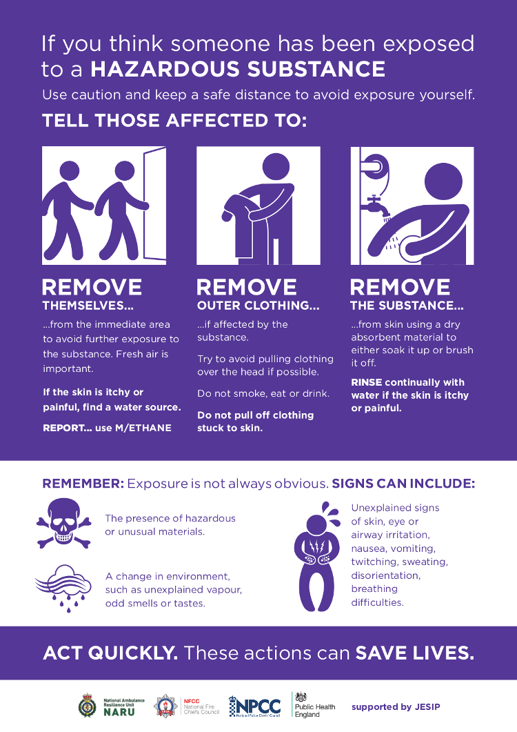

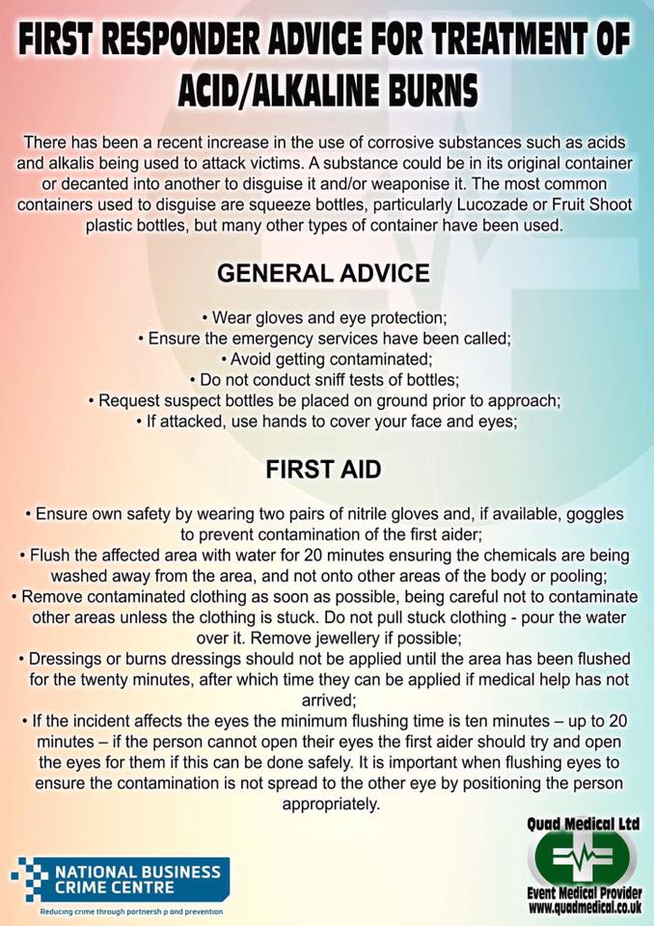

Heat wave plan

Large public events increase exposure to heat and direct sunlight and can make organisational responses more difficult. Individual behaviours often change (for example people may be reluctant to use the toilet facilities due to long queues and purposely reduce fluid intake). At many large events, people get into a good position to see the event and then reduce fluid intake and heat avoidance behaviours so as no to loose their spot. This can lead to heat related illness, dehydration and/or collapse (Public health England & NHS England 2014).

In the event of the met office declaring a heat wave level 2 and above QML shall provide the following response:

|  |  |
| --- | --- |
| Within the First aid post | |
| Response from duty managers | -Make staff announcement to follow heatwave business continuity plans and make them accessible to staff  - Ensure cooling of the first aid post environment by installation of mobile fans  - Ensure there is a plentiful supply of drinking water for staff and patients by liaising with event control  - Ensure staff have access to sun protection including caps and sun cream  - Ensure staff are taking regular breaks from the direct sun and consuming adequate amounts of water  -Remind staff of signs and symptoms and treatment of heat related illness |
| Response from Medical staff | - Identify vulnerable patients including those with pre-existing chronic conditions such as asthma, heart disease etc who are vulnerable to the effects of heat and increase frequency in monitoring and fluid intake where necessary  - Recognise and treat sunburn, heat stroke and heat exhaustion as appropriate  - Don relevant protective equipment such as baseball caps |
| Response from welfare | - Ensure there is an adequate supply of sundries such as sun cream and baseball caps for clients and alert the duty manager when stocks have reached 50%  - identify those at risk of medical intervention who have attended for rest and recuperation i.e. those who are lethargic, confused, dizzy and notably sunburnt and escalate their care to the medical staff for review. |
| Response on event site outside of first aid post | |
| Duty managers | - ensure that all staff are accounted for and are offered the opportunity to return to the medical tent for rest and rehydration  - ensure that remaining staff on site patrol areas of public vulnerability such as mid-crowd  - ensure appropriate uniform is supplied to protect the QML team from direct sunlight  - liaise with event control and ELT at regular intervals to identify any trends in patient presentation and heat related illness and use accurate real time data from presenting patients to form a plan to mitigate any ongoing risks. |
| Response from roaming medical and welfare staff | - ensure any patrons on the event site found sleeping are roused and assessed for effects of heat related illness  - Assess those they come into contact with, for heat related illness  - offer assistance and contact intervention such as sun cream and directions to water points and advice on avoiding heat related illness  - patrol event sites as directed by QML control paying particular attention to densely populated areas where event participants may gather without shade and fluid intake for prolonged periods i.e. mid crowd. |

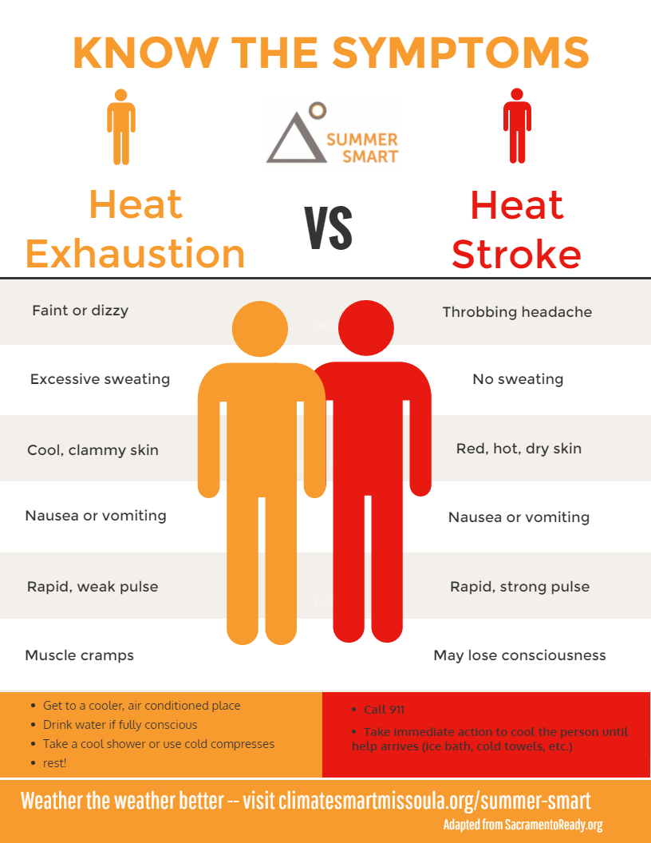

Treatment of heat exhaustion:

Staff will monitor patients with suspected heat exhaustion in the majors area and:

1. Provide water to the patient and encourage oral intake
2. Place patient near cooling fans
3. Provide dignity and privacy where clothing needs to be removed to facilitate cooling
4. Monitor basic vital signs and respond appropriately as guided by clinical judgement and NEWS2 score

Treatment of heat stroke

1. Interventions as above +
2. Ensure a registered person or the clinical lead has assessed the patient
3. Registered persons to administer where appropriate IV fluid resuscitation
4. Consider severity and treatment options available vs hospital transfer

Catering

Staff meals will not be provided at this event. Staff are welcome to bring their own food with them to the event. There will also be several food outlets on site for staff to purchase food. Staff, are reminded that they are not permitted to consume food within the clinical areas. Suitable break areas will be designated on the event day by the duty manager. We recommend that staff bring bottled water with them to the event to stay hydrated.

Lost Property

Any lost property items recovered by QML staff need to be handed into the information point ASAP.

Stand Down

Event control will give instructions to the QML duty manager for stand down, who will stand staff down as appropriate in a timely fashion.



|  |  |
| --- | --- |
| METHOD STATEMENT & RISK ASSESSMENT (RAMS) SAFE PLAN OF WORK | |
| Client: | Broadwick |
| Site: | Royal Docklands |

|  |  |
| --- | --- |
| Prepared By: | Paul Saddington |
| Position: | Director |
| Date: | 19/2/23 |
| Scope of Work | Medical Cover |

.

Contacts and Site Management Team:

Office contact and emergency number: 07904 706 660

|  |  |  |
| --- | --- | --- |
| Our Main Office: | | t: 07904 706 660 |
|  | | |
| Medical Team Mobile No’s | | |
| Name | Position | Mobile No |
| Paul Saddington | Manager | 07904 706 660 |
| Caroline Medcraft | Duty Controller | 07746969125 |

Health and Safety at Work Act 1974

This is the Health and Safety Policy Statement of

Quad Medical Limited

As providers of on-site medical services Quad Medical Limited (QML ) is committed to maintaining a safe working environment for its employees and strives to promote safe working practices and safe environments for all staff and the public in consultation with our clients and working partners.

As an integral part of the health and safety measures deployed on sites and locations where we operate it is an objective of this company and its staff to lead by example in all aspects of our own Health and Safety affairs.

**Our statement of general policy is:**

* To promote a working environment where every member of staff accepts that they play an integral part to play in maintaining the safety of themselves and others around them.
* To facilitate a process whereby opinions, observations and concerns raised by staff on matters of Health and Safety are encouraged, noted and acted upon as a matter or priority.
* To provide adequate control of the health and safety risks arising from our work activities both on our premises and whilst working on sites and locations.
* To consult with all permanent and part time employees on matters affecting their health and safety;
* To provide and maintain safe plant, equipment and vehicles.
* To ensure safe handling and use of substances, medical products, medical gasses, sharps and cleaning products.
* To provide information, instruction and supervision for employees where not included as part on their pre-existing professional training; or to refresh and update such training as necessary.
* To ensure all employees are competent to do their tasks, and to give them adequate additional training as required.
* To prevent accidents and cases of work-related ill health.
* To maintain safe and healthy working conditions and, if necessary to work with and advise clients to ensure a safe working environment for our employees whilst working on site or location.
* To review and revise this policy as necessary at regular intervals.

Signed

PAUL SADDINGTON

Managing Director

Date 14/5/19

**Health & Safety Organisation within QML**

1. Overall and final responsibility for health and safety is that of:

PAUL SADDINGTON – Managing Director

2. Day-to-day responsibility for ensuring this policy is put into practice is delegated to PAUL SADDINGTON

3. All employees have to:

* Co-operate with the company on health and safety matters.
* Not interfere with anything provided to safeguard their health and Safety.
* Take reasonable care of their own health and safety
* Report all health and safety concerns to a member of the management team or a responsible representative of the site they are working on (if appropriate) as soon as is practical.

**Responsibilities**

* Risk assessments will be undertaken by PAUL SADDINGTON

Action required to remove/control risks will be approved by PAUL SADDINGTON

* All staff and employees will be responsible for ensuring the action required is implemented.
* PAUL SADDINGTON will check that the implemented actions have removed/reduced the risks.

Assessments will be reviewed every 6 months or when the work activity changes, whichever is soonest.

**General Health & Safety Arrangements**

**Plant and equipment**

PAUL SADDINGTON will check that new plant and equipment meets health and safety standards before it is purchased, that it is maintained in accordance with manufacturer’s guidelines and that any reported defects are remedied at the earliest opportunity.

Responsibility for reporting defects and problems with any plant or equipment is that of every member of staff using the equipment and problems or defects should be notified to the office at the earliest opportunity or, in the case of vehicle defects, noted clearly on daily log sheets.

**COSHH**

PAUL SADDINGTON will be responsible for identifying any substances which need a COSHH assessment and for undertaking COSHH assessments. At present the only materials identified as potentially harmful in the context of COSHH would be vehicle cleaning materials

**First Aid**

The first aid box(es) is/are kept in the Office / medical center. Also in every marked and unmarked vehicle and at venues, event sites or temporary work places.

The appointed person(s)/first aider(s) is/are PAUL SADDINGTON – although other suitably qualified medical staff are available at each workplace or location.

All accidents and cases of work-related ill health are to be recorded on QML patient report forms. One of the named first aid appointees MUST be informed of any injury occurring to a staff member.

PAUL SADDINGTON is responsible for reporting accidents, diseases and dangerous occurrences to the enforcing authority.

**Information and Advice**

The Health and Safety Law poster is displayed at Head Office, QML London. Health and safety advice is available from PAUL SADDINGTON.

PAUL SADDINGTON is responsible for ensuring that our employees working at locations under the control of other employers, are given relevant health and safety information – in consultation with clients or owners / operators of sites or locations.

Whoever is allocating jobs and passing job details to employees will pass on any relevant health and safety information including daily location or risk assessments as provided by the client. This will include stunt and special effects information.

When operating on site and at large events the duty manager or event medical officer shall ensure that all staff are familiar with site risk assessments, site evacuation plans and major incident plans.

General information relating to all aspects of our H&S policy and specific information relating to the duties and responsibilities of each member of staff in relation to the avoidance of risk, reporting of accidents or dangerous occurrences and use of PPE etc. are clearly described in the staff handbook issues to all staff.

**Fire**

Fire Extinguishers are available and clearly marked in all vehicles and on all premises. It is the responsibility of every employee to familiarize themselves with the position and operation of fire extinguishers as well as the location of appropriate exits and emergency exits.

**Special Risks:**

**Staff Working at Event Venues**

Medical Staff will be issued with specific briefing information (A Venue Medical Plan) for each venue. There will also be a Method Statement in relation to the venue. Event-specific details will be provided via the event organizer in relation to each event. Where required, a specific risk assessment will be carried out in relation the event or activity taking place in the venue.

**Risk Rating Guidelines**

The Hazard RISK Rating (HRR) is given by the expression: The hazard risk rating is classified as HIGH, MEDIUM, or LOW according to the numerical value. The Action required is guided by the risk rating attributed to each risk.

**Calculating Hazard Risk Rating = Consequence x Probability**

|  |  |  |
| --- | --- | --- |
| **Probability of hazard occurring** | | |
| **Probability/likelihood** | **Description** | **Score** |
| Likely/foreseeable | Occurs repeatedly/ to be expected. | 5 |
| Probable | Will occur several times. | 4 |
| Possible | Conceivable (could occur sometimes) | 3 |
| Remote | Unlikely though still conceivable | 2 |
| Improbable | So unlikely that probability is close to zero. | 1 |

|  |  |  |
| --- | --- | --- |
| **Consequence of hazard occurring** | | |
| **Consequence** | **Description** | **Score** |
| Catastrophic | Death | 5 |
| Major | More than a seven day absence from work or permanent disability | 4 |
| Moderate | Up to three days absence from work | 3 |
| Minor | Minor injuries requiring first aid | 2 |
| Insignificant | No injury | 1 |

|  |  |  |  |  |  |
| --- | --- | --- | --- | --- | --- |
| **Hazard Risk Matrix**  **Consequence x Probability** | | | | | |
| **Probability** | **Likely**  **(5)** | **Probable**  (4) | **Possible**  (3) | **Remote**  (2) | **Improbable**  (1) |
| **Consequence** |
| Catastrophic (5) | High  (25) | High  (20) | High  (15) | Medium  (10) | Low  (5) |
| Major (4) | High  (20) | High  (16) | Medium  (12) | Medium  (8) | Low  (4) |
| Moderate (3) | High  (15) | Medium  (12) | Medium  (9) | Low  (6) | Low  (3) |
| Minor (2) | Medium  (10) | Medium  (8) | Low  (6) | Low  (4) | Low  (2) |
| Insignificant (1) | Low  (5) | Low  (4) | Low  (3) | Low  (2) | Low  (1) |

|  |  |  |
| --- | --- | --- |
| **Action Level Table** | | |
| **Risk Rating** | **Probability x Consequence** | **Action** |
| 20-25 | High Risk | STOP – stop the activity and take immediate action |
| 15-19 | High Risk | Urgent Action – Take immediate action and stop activity if necessary, maintain existing controls vigorously |
| 8-14 | Medium Risk | Action – Improve within specific timescales |
| 3-7 | Low Risk | Monitor – Look to improve at the next review or if there is a significant change |
| 1-2 | Low Risk | No Action – No further action but ensure controls are maintained and reviewed |

|  |
| --- |
| **IDENTIFIED HAZARDS** |

1. Work Area
2. Manual Handling
3. Access to work place
4. Work Equipment
5. Storage of Equipment
6. Vehicle Movement
7. Noise
8. Needles and Sharps
9. Working Near Public
10. Weather
11. Injuries to staff
12. Compressed Gasses
13. Blood Products

|  |  |  |  |
| --- | --- | --- | --- |
| **RISK ASSESSMENT** | | | |
| **1. Hazard: Work Area; 4 x 4 = 16** | | **Pre Control Risk** | **High** |
| **Who might be Harmed and How:**  QML Staff, General Public, Visitors, Other Trades. Wells disease, infectious diseases, Vapors, fumes inhalation, respiratory problems, Sharps, needles and other disposed items causing cuts & abrasions. Splinters from boards and sheet material. Gashes and tears to skin from working, build/break of event, discarded needles, sharp edges. Working in un-assessed enclosed areas. | | | |
| **Control Measures** | | | |
| Information and instruction. Site induction and briefings by QML Staff. Provision of P.P.E., i.e. gloves and safety glasses and hi visibility tabard. Inspection of materials prior to first use. Trained, competent and skilled operatives. Notices and signs displayed at staff high traffic areas. Inspect work area prior to commencement of work. Report unsafe work areas. Wash hands thoroughly prior to eating. Use antiseptic wipes and plasters to all cuts and abrasions. Do not handle foreign objects or items. General personal hygiene. Get cuts and grazes properly cleaned and treated immediately and keep covered with a waterproof dressing. Always wash hands thoroughly on leaving the building and before eating or smoking. Wear personal protective equipment, gloves. Use barrier creams. If flu like symptoms are felt consult medical professional immediately and inform of rat infested workplace. If a cut or graze becomes infected get treated by your GP immediately. | | | |
| **Post Control Risk; 2 x 4 = 8** | **Medium** | | |

|  |  |  |  |
| --- | --- | --- | --- |
| **2. Hazard: Manual Handling; 4 x 5 = 20** | | **Pre-Control Risk** | **High** |
| **Who might be Harmed and How:**  Operatives. Strains and sprains. Musculoskeletal disorders. Uneven terrain increases the risk of Musculoskeletal injures. | | | |
| **Control Measures** | | | |
| Always avoid manual handling where possible and if necessary use mechanical means where possible.  Manual handling training has been given to all QML staff via Competent CSTF aligned provider/trainer.  Operatives to use correct manual handling techniques. Personal protective equipment to be worn at all times. Regular breaks taken from repetitive work activity.  Work tasks varied to avoid repetition.  Each operation planned.  Access routes maintained at all times.  Operatives never to exceed their physical capabilities. Regular refresher talks delivered to all operatives.  Always consider the Task, Individual, Load and The Environment.  Never lift anything above personal capabilities.  Apply correct lifting technique.  Never carry anything without a clear field of vision ahead of you.  Always ask for help if the load is too heavy, bulky or hazardous.  All terrain vehicle available for accessing and conveying patients who have become ill or injured in areas located across uneven terrain. | | | |
| **Post Control Risk: 3 x 3 = 6** | **Low** | | |

|  |  |  |  |
| --- | --- | --- | --- |
| **3. Hazard: Access to Workplace: 4 x 4 = 16** | | **Pre-Control Risk** | **High** |
| **Who might be Harmed and How:**  Operatives. Slips, trips and falls at same level. | | | |
| **Control Measures** | | | |
| Site ground conditions maintained by main contractor. Safe routes designated.  Segregation of operatives from vehicular movement.  All temporary/permanent ladders safely erected and secured.  High levels of housekeeping maintained.  All operatives to follow site instruction. PPE to be worn at all times.  Any unsafe access, out of own control, reported.  Avoid working on icy or un even surfaces. Where this is not practicable the all terrain vehicle can be deployed in addition to all staff wearing adequate safety footwear whilst on site.  All access routes planned.  Where practicable do not stray off designated walkways, safe routes and Fire escape routes.  Report all unsafe conditions to the main event controller | | | |
| **Post Control Risk : 2 x 4 = 8** | **Medium** | | |

|  |  |  |  |  |  |  |  |  |  |  |
| --- | --- | --- | --- | --- | --- | --- | --- | --- | --- | --- |
| **4. Hazard: Work equipment; 4 x 4 = 16** | | | | | **Pre Control Risk** | | **High** | | | |
| **Who might be Harmed and How:**  Operatives, General Public, Visitors, Other Trades. | | | | | | | | | | |
| **Control Measures** | | | | | | | | | | |
| All medical materials to comply with British and European Standards.  All materials inspected before and after use.  Statutory inspections carried out as per the Medicines and health care regulatory agency standards.  Out of Date or defective equipment discarded and permanently put out of use as per the QML equipment management policy. All medical equipment maintained to high standard.  All defects reported. Special attention is required with defibrillators which must be maintained in line with the manufacturers guidance and that of MHRA.  Do not use any work equipment that you are not trained and competent to do so.  Ensure, before use, all electrical equipment displays a current Portable Appliance Test Certificate. | | | | | | | | | | |
| **Post Control Risk: 1 x 4 = 4** | | **Low** | | | | | | | | |
|  | | | | | | | | | | | |
| **5. Hazard: Storage of material; 4 x 4 = 16** | | | | | | **Pre Control Risk** | | | **High** | | |
| **Who might be Harmed and How:**  Operatives, co-workers, members of the public. Slips, trips and falls. Collision | | | | | | | | | | | |
| **Control Measures** | | | | | | | | | | | |
| Designated storage areas of medical equipment in vehicles or suitable storage bags.  All materials when not in use to be stored on vehicle or within the designated flight case or area within the medical tent.  Safe pedestrian routes established around work areas.  Agreed designated storage areas to be agreed with customer/client in advance.  Good housekeeping standards maintained at all times.  Keep material stored in good order, segregated and in size order. | | | | | | | | | | | |
| **Post Control Risk: 1 x 4 = 4** | **Low** | | | | | | | | |
|  | | | |  | | | |  | | | |
| **6. Hazard: Vehicular movement; 4 x 4 = 16** | | | | **Pre Control Risk** | | | | **High** | | | |
| **Who might be Harmed and How:**  Operatives, third parties, property. Collision, Impact, Crushing. | | | | | | | | | | | |
| **Control Measures** | | | | | | | | | | | |
| Vehicular movement on site only permitted with the use of a banks-man.  Speed limit kept to a minimum.  Segregation of personnel and traffic.  Reversing lights/alarms used on vehicles.  All operatives to wear Hi-Visibility vests  Site Traffic Management Plan in Place.  All operatives to read and fully understand Site Traffic Management Plan.  Site Operatives to follow site designated safe route.  Be aware, be safe and be seen.  Remain in demarcated work areas. | | | | | | | | | | | |
| **Post Control Risk: 1 x 4 = 4** | | | **Low** | | | | | | | | |

|  |  |  |  |  |  |  |  |
| --- | --- | --- | --- | --- | --- | --- | --- |
| **7. Hazard: Noise; 4 x 4 =16** | | | | **Pre Control Risk** | | **High** | |
| **Who might be Harmed and How:**  Operatives, co-workers, members of the public. Industrial deafness | | | | | | | |
| **Control Measures** | | | | | | | |
| Strictly follow the Control of Noise Regulations 2005. Maintain noise levels to a minimum. Hours of work specified by principle contractor. First action level 80db, second action level 85db. Regular tool box talks carried out. Adequate supervision and control. Carry out noise analysis if necessary. Display hazard warning signage.  No QML Staff to work in ANY area with excessive noise unless wearing appropriate protective equipment such as ear defenders. Follow event management noise plan and risk mitigations.  Remember hearing damage or loss is irreversible, you only have two ears-Looks after them, industrial deafness is for life!! | | | | | | | |
| **Post Control Risk: 1 x 4 = 4** | | **Low** | | | | | |
|  | | | | | | | |
| **8. Hazard: Needles/Sharps (COSHH); 4 x 4 = 16** | | | | | | **Pre Control Risk** | | **High** |
| **Who might be Harmed and How:** | | Site Operatives, Visitors.  Disease, infection; Fatal, Serious illness. | | | | | | |
| **Control Measures** | | | | | | | | |
| Inspect all work areas prior to starting work. Do not put hands in places where you cannot see. Refuse to work in areas contaminated with used needles, until such times as they are cleaned out, the work area re-inspected and the all-clear given.  QML Staff are trained in safe needle and sharp procedures.  Dispose of all sharps in correct sharps boxes as and when they are used.  Do not handle foreign objects. Inform line management. Wash hands thoroughly before eating or smoking. Wear Gloves. Seek medical attention if experiencing adverse symptoms. | | | | | | | | |
| **Post Control Risk: 2 x 4 = 8** | | | | **Medium** | | | | |

|  |  |  |  |
| --- | --- | --- | --- |
| **9. Hazard: Work adjacent to the general Public; 4 x 4 = 16** | | **Pre-Control Risk** | **High** |
| **Who might be Harmed and How:**  Operatives, general Public. Fatal, Serious Injury. | | | |
| **Control Measures** | | | |
| Restrict access to medical areas.Triage staff will be present at the entrance of the medical tent at all times.  Safe pedestrian routes established around Medical work area. Physical barriers, hoarding, fencing, or barrier tape,. A respectful and courteous manner maintained at all times. Cooperate fully with all members of the public. Maintain a un-confrontational demeanor at all times. | | | |
| **Post Control Risk; 1 x 4 = 4** | **Low** | | |

|  |  |  |
| --- | --- | --- |
| **10. Hazard: Adverse weather; 4 x 4 = 16** | **Pre Control Risk** | **High** |
| **Who might be Harmed and How:**  Operatives. Hyperthermia, skin cancer. | | |
| **Control Measures** | | |
| Follow operational plan and business continuity plan. Wear appropriate PPE for both hot and cold temperatures, including sun block cream in sunny conditions. | | |
| **Post Control Risk: 1 x 4 = 4** | **Low** | |

|  |  |  |  |
| --- | --- | --- | --- |
| **11 Hazard: Injuries to Medical Staff: 2 x 4 = 8** | | **Pre-Control Risk** | **Medium** |
| **Who might be Harmed and How:**  Use of Medical equipment.. Operatives, Minor/Major Injury. | | | |
| **Control Measures** | | | |
| Ensure only trained and competent staff use equipment.  Regular certified inspection for all equipment. Ensure all R/A and Methods of safe working are adhered to. Disinfectant and cleaning materials available for items before and after use with hand washing adhered to prior to and post cleaning. Asset logging of equipment for appropriate tracking and assurance in equipment management. Checking of all equipment and disposables prior to use. Quarantine, labelling, Reporting and replacement if items are found to not be suitable for use. | | | |
| **Post Control Risk; 1 x 4 = 4** | **Low** | | |

|  |  |  |  |
| --- | --- | --- | --- |
| **RISK ASSESSMENT** | | | |
| **12. Hazard: Compressed Gasses 4 x 4 = 16** | | **Pre Control Risk** | **High** |
| **Who might be Harmed and How:**  Operatives, general Public. Fatal, Serious Injury. | | | |
| **Control Measures** | | | |
| Information and instruction. Site induction and briefings by QML Staff. Provision of P.P.E., i.e. gloves and safety glasses. Inspection of Gas cylinders prior to first use. Trained, competent and skilled operatives.  All cylinders appropriately tested and in date stickers checked prior to use.  Suitable and sufficient storage and carrying of gas cylinders. Correct markings on vehicle stored correctly in compliance with manufacturer’s instructions.  Only trained staff to use transport handle or change gasses. Designated area for housing of gas cylinder in an appropriate protective case within the medical facility (Crash trolley within resus area). | | | |
| **Post Control Risk; 1 x 4 = 4** | **Low** | | |

|  |  |  |  |
| --- | --- | --- | --- |
| **13. Hazard: exposure to blood products 4 x 4 = 16** | | **Pre-Control Risk** | **High** |
| **Who might be Harmed and How:**  Operatives, general Public. Fatal, Serious Injury. | | | |
| **Control Measures** | | | |
| Restrict access to medical waste  Trained staff only to deal with Blood or medical waste.  Sterile gloves to be worn when handling or likely to handle infectious waste. Strict hand hygiene procedures followed when handling waste. Hand washing and waste management incorporated into staff mandatory training and within medical management plan.  Eye protection to be worn if needed.  All waste products to be disposed of In clinical waste bags and disposed of appropriately as per company policy. | | | |
| **Post Control Risk; 1 x 4 = 4** | **Low** | | |

**Personal Protective Equipment (P.P.E.):**

All operatives will be provided with and if instructed to wear at all times whilst on site, the appropriate P.P.E. i.e.

* Safety hat
* Safety boots
* High visibility vest
* Safety gloves
* Protective eye wear
* Apron
* Gown

Any loss or defect identified to be reported immediately and work activity ceased until replacement P.P.E. provided.

1. **PPE Specification**

|  |  |
| --- | --- |
| PPE | |
| TYPE | STANDARD |
| Hard Hats | BS EN 397 |
| Hi-Vis Vests | BS EN 471 |
| Boots | BS EN 345 |
| Gloves | BS EN 388 |
| Light Eye Protection | BS EN 166 |
| Safety Goggles | BS EN 166 |